**GEOG 3106-6306: Uzbekistan’s Sardoba Dam Failure**

**Georeferencing [and Disaster Relief] Assignment**

**Scenario:** *Today is May 8, 2020, and the first day with sparse enough cloud cover in order to collect quality satellite imagery of northern Uzbekistan. Just a week prior, on May 1, 2020, the western wall of a dam that surrounds the Sardoba Reservoir partially collapsed, releasing tons of water and flooding the area north of the reservoir. The Government of Uzbekistan needs the help of GIS technicians in order to create two maps; one map will help the government understand the size of the area flooded on the Uzbek side of the border and the second map will be used by disaster response teams in order to navigate from Gulistan/ Guliston to the impacted area in order to save those who remain.*

For this assignment you must georeference the initial extent of the Sardoba Reservoir as well as the flooded area using ArcGIS Pro. The collection of maps is urgently needed in order to inform disaster response personnel about who still needs saving and quality contextual information.

The final report should be a minimum of 1.5 (maximum of 2) pages plus two pages for maps, single spaced with responses to each question found below (the page count includes two maps on separate pages). Please use iconography where appropriate to illustrate roads and sites of importance in the flooded area.

Watch the video below for a glimpse at the extent of flooding: [Video - Uzbekistan Sardoba dam bursts in Uzbekistan May 1st 2020](https://youtu.be/wGUJ0aP9c54)

**Section 1 – Creating Data in an Emergency Setting**

## Emergencies commonly occur in regions with poor spatial data infrastructure and weak data sharing mechanisms, and spatial data can quickly become outdated in the chaotic, dynamic conditions of disaster. Unless new data is periodically collected and added to agency geodatabases, organizations are limited in their ability to support better decision making.

## Understanding how to populate a geodatabase is therefore an essential skill for a GIS specialist. In this exercise you will create a new geodatabase from data collected online, you will rectify before and after imagery for a flooding scenario, and you will make a situation report map for your organization.

# Section 1.1 – Online Data Mining

*For this lab you will collect spatial data online from three different sources:*

* *DIVA GIS (you will download this yourself)* 
  + [*http://www.diva-gis.org/gData*](http://www.diva-gis.org/gData)
* *Earth Explorer Landsat 8 Aerial Imagery (downloaded for you and available through Blackboard)*

1. In DIVA, choose *Uzbekistan* from the Country dropdown list and Administrative Areas (UZB_adm) from the Subject dropdown list. You will be taken to a new window that previews the spatial data that you are about to download. Click download and save the data to your Exercise01 folder on GW’s servers. Also download the following other datasets: Inland water (UZB_wat)*, roads (UZB_rds), gazetteer (UZB_gaz).
2. The images of the flood have been downloaded for you and are located in the assignment page on Blackboard. The first image is from April 22, 2020 — before the dam broke due to heavy rains. The second image is from May 8, 2020 and is the clearest possible image following the dam breach.

*Most of these files are zipped for efficient downloading so it will be necessary to unzip them in order to perform all analysis. It is recommended that all files are unzipped in the Lab 1 folder within your S drive folder.*

*\*Also note that sometimes GIS data can be antiquated and thus inaccurate; check the size of the Aral Sea.*

# Section 1.2 - Building Geodatabases and Generating Data

## Spatial data comes in many formats, all of which can be managed in the Catalog view/pane and added to ArcGIS Pro as independent layers. These formats include: shapefiles, coverages, CAD files, and feature classes and feature datasets in geodatabases. Geodatabases allow you to organize data into groups of similar feature classes. A feature class is a group of points, lines or polygons representing geographic objects of the same kind, such as counties, cities, rivers or roads. Geodatabases also allow groups of end users to access the same data without interfering with one another.

## 

## You will use the Catalog to create and manage a geodatabase for Uzbekistan. Using the Catalog view you will build the file structure for new feature classes. Then you will use the Editor Toolbar to add new features to this feature class, and then edit their attributes. You will also learn how to georeference imagery in order to collect data for your geodatabase.

### Process –– Basic Geodatabase Operations in ArcGIS Pro

1. Open ArcGIS Pro and use the Search bar or View tab to open the Catalog View.
2. With the Catalog tab selected, navigate to Contents and find the Folders section. From here you must add a folder connection to the folder which contains your Uzbekistan files.
3. Make this folder the default. Within your folder, right click and create a new File Geodatabase. Title it *Uzbekistan*. Set this *Uzbekistan.gdb* as the default as well.

|  |
| --- |
| *The objective of this part of the exercise is to organize the files you have downloaded and group*  *them according to thematic type, such as Admin, Transportation, Hydrology, etc. The files will be*  *grouped in the Geodatabase as Feature datasets. Feature datasets are a collection of feature*  *classes sharing the same spatial reference.* |

1. Right click on *Uzbekistan.gdb* and create a new feature dataset. Name it *Hydrology*. Set the coordinate system to *UTM WGS 1984 Zone 42N* under Projected Coordinate Systems.
2. Use the default for the rest of the options.
3. Right click on the new Hydrology feature dataset and import Feature Class(es).
4. Add the following files from your Lab 1 folder and Run the process (it might take a few minutes):
   1. UZB_water_areas_dcw.shp
   2. UZB_water_lines_dcw.shp
5. Using the previous steps, create *Feature Datasets* for the categories listed below and *make sure to assign the correct projection for each dataset*.
   1. **Admin**
      1. UZB_adm0
      2. UZB_adm1
      3. UZB_adm2
      4. Settlements (*from gazetteer –– instructions to follow to add X,Y data*)
   2. **Transportation**
      1. UZB_roads
   3. **Hydrology** (*you’ve already created this*)
      1. UZB_water_area
      2. UZB_water_lines
   4. **Ground Reports**
      1. Ground_Reports
6. Import the images (*LC08_L1TP_154032_20200508_20200526_01_UN.tif* and *LC08_L1TP_154032_20200422_20200508_01_T1.tif*) which correspond to the imagery after the disaster and before the disaster, respectively. In order to do this you will need to find the “Raster to Geodatabase” conversion tool in the search bar and input your two files with *Uzbekistan.gdb* as your output.
7. 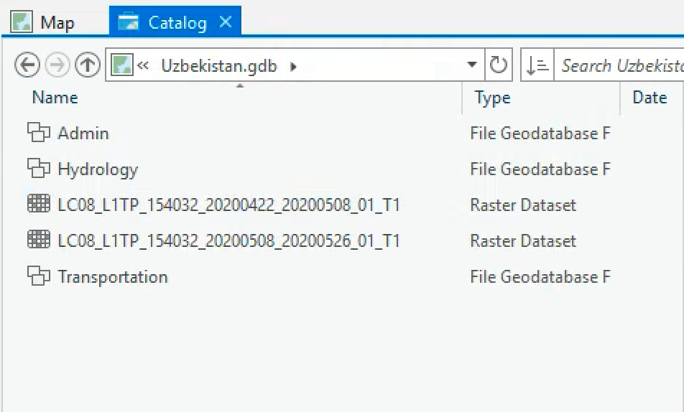Examine Ground_Reports this will help you later in this lab.
8. Save your project.

### Create a Data Layer from a List of XY Coordinates

## In addition to data sources, such as a shapefile, you can also add tabular data that contains geographic locations in the form of XY coordinates to your map. XY coordinates describe discrete locations on the earth's surface, such as the location of hospitals in a city or the points where water samples were collected. IN THIS CASE the coordinates are the location of settlements. XY coordinate data is collected using a Global Navigation Satellite System (GNSS) receiver (more commonly referred to as a “GPS”). Unfortunately, the data collector may not always have access to GIS software in the field for direct upload of point information, therefore they must download and disseminate the coordinate information as a regular database file.

## 

## To add a table of XY coordinates to your map, the table must contain two fields, one for the X coordinate and one for the Y-coordinate. The values in the fields may represent any coordinate system and units such as latitude and longitude or meters.

1. While in the same ArcGIS Pro session, switch to the map view from the catalog view.
2. From the Lab 1 folder, find and add the “UZB.dbf” file (from the Gazetteer download). Right click to open the table view.
   1. In columns 5 and 6 in the table you can find the Latitude and Longitude values for every inhabited place in Uzbekistan.
3. You may have noticed that the Lat/Lon data is stored as text instead of actual coordinates. Therefore, these inhabited areas cannot be immediately added to the map. It is necessary to add two more fields stored as ‘Float’ in terms of datatype in order to get these places to appear in your cartographic product (Hint: use the field calculator).
4. Close the table and under Add Data, Add the XY Data just created.
5. Use UZB as your input table. Populate the X Field with your newly created Longitude (LONG1) and Latitude (LAT1) fields, as indicated on the right. For the coordinate system, select GCS_WGS_1984 if it isn’t already.
6. Click Run.
7. If the geoprocessing was successful, you should see many places populate throughout Uzbekistan. To verify that the layer is contiguous with other layers in your data repository, add a couple more layers from your geodatabase.
8. To transform the cosmetic layer into a permanent layer, export the point data and save it to the Admin Feature Dataset in your geodatabase. Name the file *UZB_Places_pt.*

## The nice thing about adding data to a Feature Dataset within a Geodatabase is that it will

## automatically adopt the projection of the parent folder.

|  |
| --- |
| **Note: We default to the path Geographic Coordinate Systems → World → WGS 1984 for both****GPS data, and data that we receive as lat/long coordinates because GPS data, and lat/long****coordinates are basically the same thing.** Essentially, the GPS unit has generated a visualoutput from lat/long readings derived by satellite. Therefore, the default coordinate systemwhen dealing with tabular lat/long information should always be Geographic CoordinateSystems → World → WGS 1984 |

## 

# Section 2.1 - Generating Data Through Digitizing and Georeferencing

## Construction of the Sardoba Reservoir was completed in 2017 after seven years of work. The Sardoba reservoir, located a few kilometers from the main flow path of the Syr Darya river, was intended to function as a source for irrigating cotton and other agricultural products in the region. The dam sustained a 922 million cubic meter capacity until a gap formed in the 29 meter tall concrete walls on May 1, 2020. It was rumored that Chinese investors signed a contract to build a hydroelectric component to be completed by 2022 ([Directors, Sardoba dam bursts in Uzbekistan 2020](https://www.hydroreview.com/dams-and-civil-structures/sardoba-dam-bursts-in-uzbekistan/)).

## 

## In this portion of the lab you will use a pair of images, one which is georeferenced, with the date 20200526, to capture the flooded area resulting from the Sardoba dam wall breach. **In the final product, it is expected that you create one detailed map indicating the extent of the Sardoba Reservoir before the dam broke, the flood path area (where the water moved) and pooled area and digitize this accordingly.**

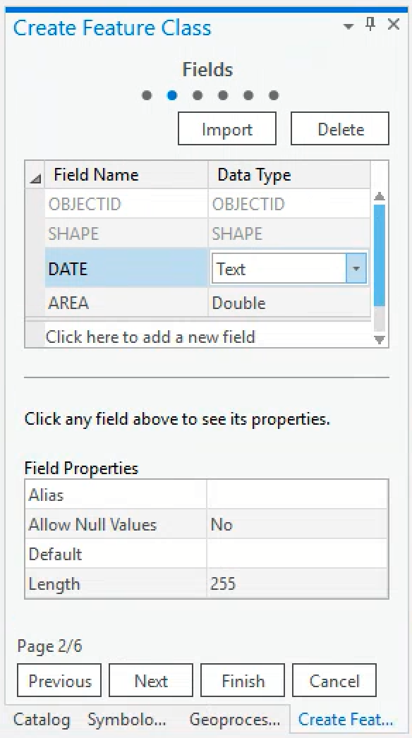

### Creating Spatial Data from Scratch

1. In the Catalog view, right click on Hydrology and add a new Feature Class. Make sure the Feature Class Type is set to Polygon.
2. Name the polygon *Sardoba_rsv*. Click to the next page.
3. Add two fields to this table and type DATE and AREA into the newly created Field Name rows.
   1. Choose Text as the data type for DATE.
   2. Choose Double as the data type for AREA.
   3. Click finish when complete.
4. Create another two polygon shapefiles named *Sardoba_floodpath_rsv* and *Sardoba_inundate_rsv* using the same parameters as the previous features.
5. 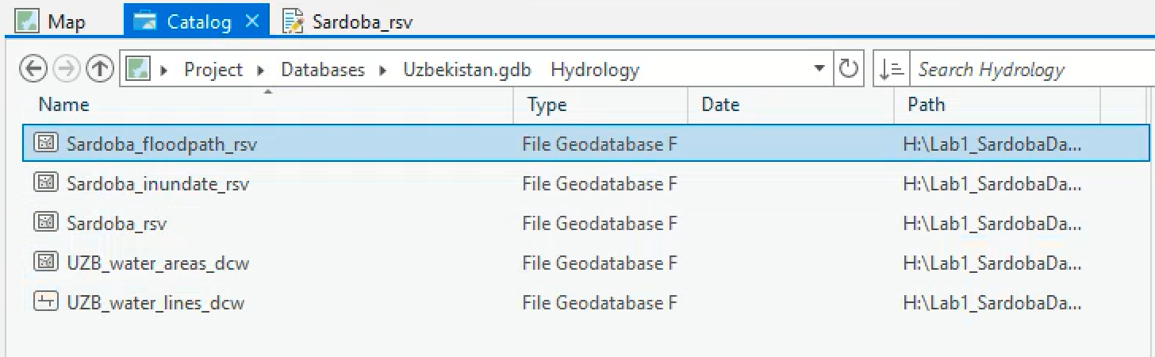Right click on the new file Sardoba_rsv and go to Properties and XY Coordinate System. You will notice that the new empty file has been assigned the same coordinate system as the other files in the Hydrology feature dataset (WGS_1983_UTM_Zone_42N).

### 

### Georeferencing

## The purpose of Georeferencing is to establish a relationship between an unreferenced scanned, paper or digital map and real-world coordinates. This is done using a georeferenced dataset, such as a roads file.

1. Switch to the Map tab from Catalog within ArcGIS Pro and open the feature classes UZB_adm2 and UZB_water_areas_dcw.
2. Return to the add data button and add the georeferenced image from April 22, 2020 (*LC08_L1TP_154032_20200422_20200508_01_T1.tif)*. This layer will serve as reference to help guide the process.
3. Explore the options at the top under Raster Layer → Appearance → Stretch Type to achieve a better visualization for your own use later on.
4. Next, add the non-georeferenced May 8, 2020 image (*LC08_L1TP_154032_20200508_20200526_01_UN.tif)* 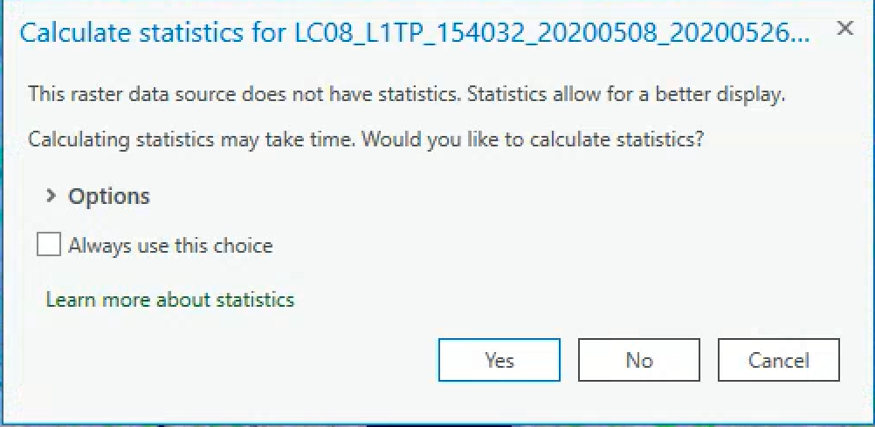to your Contents pane. You will receive the following query. Be sure to calculate statistics.
   1. You’ll notice that the 0526 dated image may not appear on the screen, or will show up in the wrong location. This is because it does not possess a spatial reference.
5. Now, go to the Command Search bar in the top right corner of your screen and type in Georeference to find the tool. Or go to Imagery > Georeference.
6. Zoom around the map to approximate the rough location of where the unregistered image should go. Then Fit To Display Fit to Display.. You can try this multiple times if the first one doesn’t work well. Optionally, use Move Move, Scale Scale, and Rotate Rotate to place the raster as needed.
7. Since 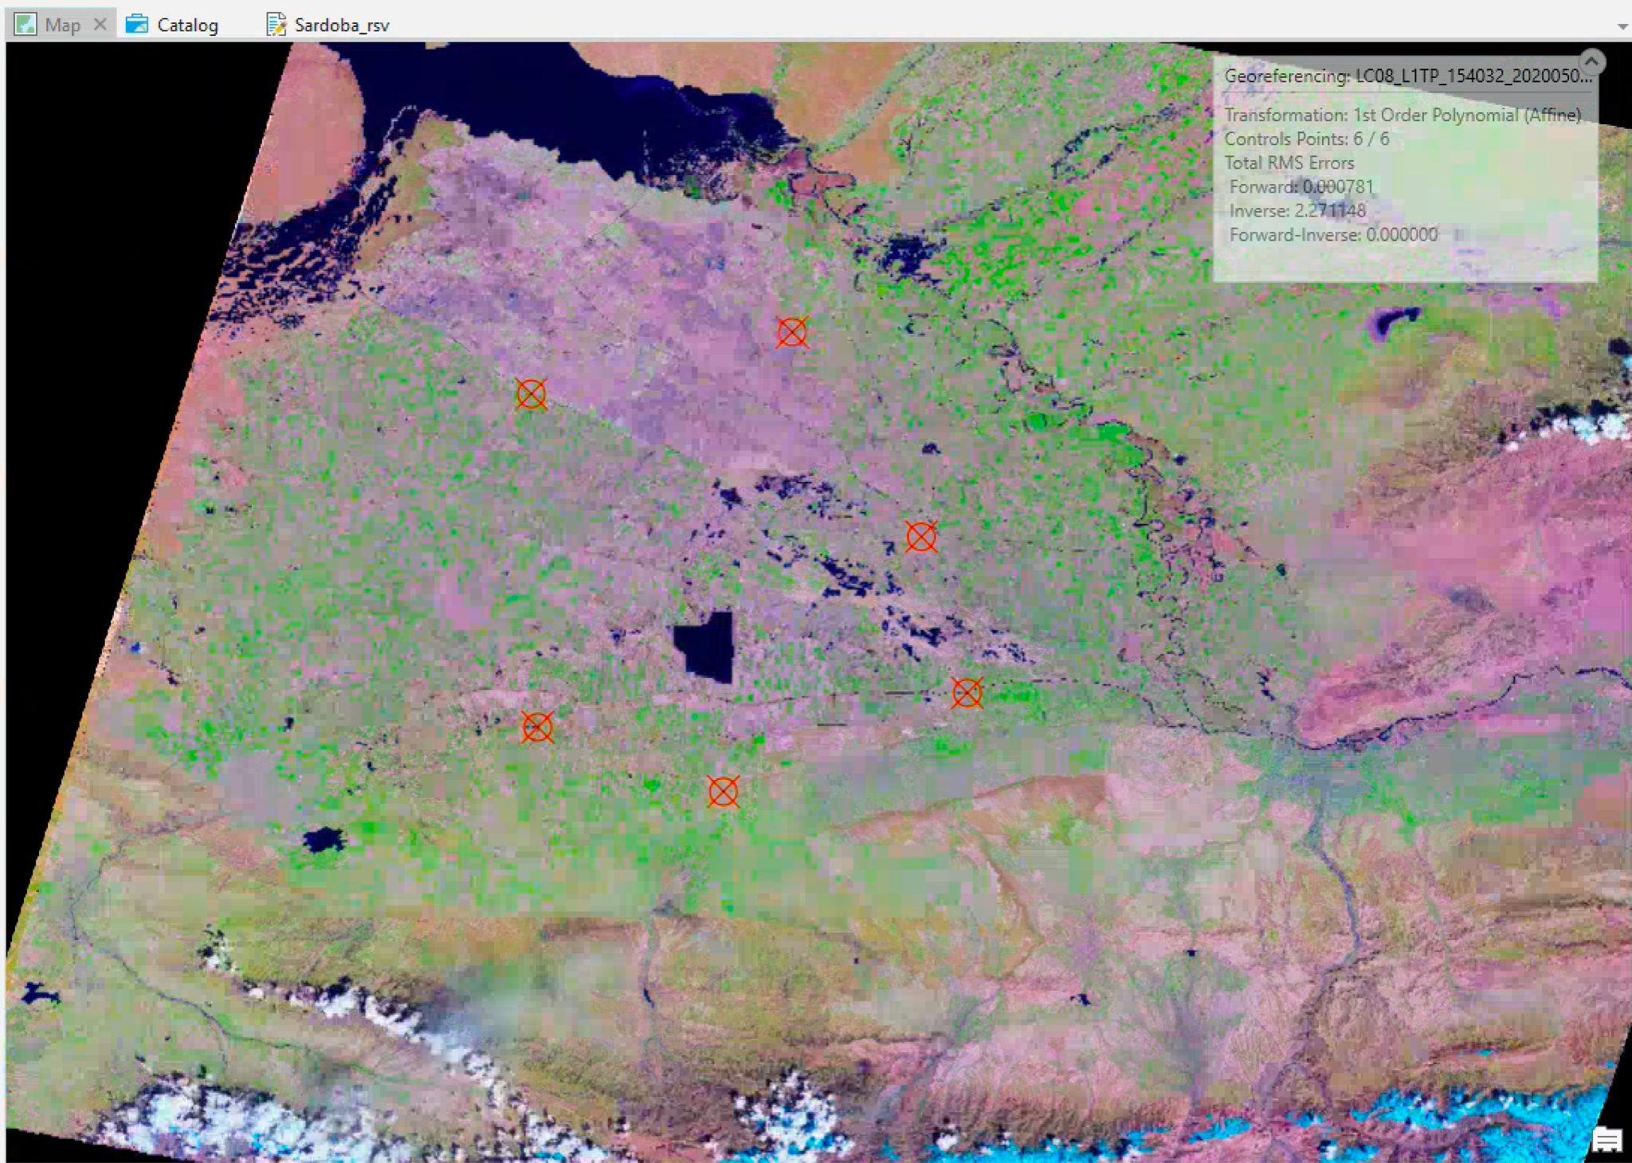*LC08_L1TP_154032_20200508_20200526_01_UN.tif* is the only unreferenced image in the window, you will need to plot control points in precise locations that are identifiable in both images.

|  |
| --- |
| Good areas for georeferencing imagery are objects such as highway intersections, buildings and other distinguishing features of the landscape. *Ideally - these features are permanent and do not change in location or shape over time.*   * Select a **minimum** of 5 control points around the flooded area. * If you find yourself needing more than 5 control points in order to get the image to line up correctly, that’s okay. It is better to have a few high-quality control points, than lots of bad ones. * The higher the quantity your control points, the more accurate your georeferencing will be. To create high quality points:   + Points should be placed on the **edge of features** (e.g. a corner of an intersection) rather than in the middle in order to match the locations more precisely in the two images.   + Points should be **spread out across the image** rather than geographically concentrated. * Since the area we are working with is relatively small, more complex **transform** methods are not needed recommended but if you wish to attempt this, keep in mind that the more complex the transformation, the more control points are needed. |

1. First, **make sure you have selected the unreferenced image in order to begin** with the Georeferencing. If you do not, you are not allowed to add control points. Now, click the add control points button to activate the tool. It will indicate when you should click on what image.
2. Remember the mantra **“Click where it is, click where it should be”**. Click first on the non-georeferenced image to set your first control point. Then, click at precisely the same location on the georeferenced image to match the control points.
3. Repeat this process until you have a minimum of 5 control points. Once you have three control points, ArcGIS Pro will match the images, so it becomes necessary to turn off one layer while lining up the points to match.
4. In the Review group, click the Control Point Table button Open Control Point Table to evaluate the residual error for each control point.
5. Press the L key to switch the transparency of your source raster on and off.
6. Delete any unwanted control points using the Control Point table. Alternatively, edit the inaccurate points by selecting them and moving the vertices.
7. When you're satisfied with the current alignment, stop entering control points.
8. In the Save group, choose how you want to persist your georeferencing information. Click save Save to associate the georeferencing information with the raster and its auxiliary files.

*It may help to rename the images in your table of contents to keep track.*

### 

### Digitizing Vector Features from Raster Data

## 

## Digitizing, the process of converting features into a digital format, is one way to create new data in ArcGIS Pro. There are several ways to digitize new features. These include digitizing "on screen" or "heads up" over an image, digitizing a hard copy of a map on a digitizing board, or using automated digitization.

## Interactive, or "heads up" digitization, is one of the most common methods, and the method that you will use for this exercise. For this method, you display an aerial photograph or satellite image on screen, and trace, or sketch features, such as roads, buildings, or parcels from the image. You will use this technique to sketch flood inundation from a satellite image of Uzbekistan.

1. Zoom to the location of the Sardoba Reservoir near the Syr Darya River in Uzbekistan.
2. Display the April image on top of the May image and find the Transparency slider under Raster Layer > Appearance. Increase the transparency to 50% on the April image to see the extent of the inundated area after the Sardoba Reservoir’s wall was breached.
3. If ArcGIS Pro hasn’t already added them, add the three layers you created from your Hydrology Feature Dataset within the Uzbekistan.gdb. At this point the only vector layers you should have open are these three as well as the April and May 2020 images.
4. Open the Edit tab and click the Create button. The three *Sardoba_rsv* files/ derivations should appear on the right side under Create Features.
5. First, you will digitize the Sardoba Reservoir at its regular level. Click on Sardoba_rsv in the Create Features frame and a toolbar should appear at the bottom of your screen.
6. Set your geometry type to polygon in order to digitize the reservoir. As you trace around the edge of the reservoir **be careful to single-click ONLY** as **double-clicking completes the sketch**.
7. While you are sketching, the polygon will fill itself in. After you have completed the sketch, an outline of your drawing will be highlighted.

## Sketching with the aid of a computer mouse is a little tricky, and is a skill improved over time. You may wish to zoom in even closer than indicated to capture the outline in even greater detail. It is possible to switch between the zoom, pan, and sketch tools interchangeably, without interrupting the sketching process, but one has to be more experienced to master this efficiently and effectively.

*You will also want to play with the image appearance>Stretch Type. In the example below changing the assignment of RGB colors helps us differentiate water, wet soil and dry fields.*

1. Go to the Edit menu and press the Save button. Also, this is a reminder to save your session if you haven’t already done so.
2. Open the attribute table for the Sardoba_rsv layer.
3. Fill in the DATE and AREA columns. Write the date as follows “2020/04/22” and input it into the table. Use the field calculator in the AREA column to display the area in square Kilometers instead of Meters. Save your changes once complete.

*Although there is already an AREA field by default – this is recorded in the units of the projection*

*which in the case of UTM is meters – this is not always convenient, therefore I like to maintain a*

*field in units such as sq miles.*

1. Next, digitize the area inundated by water *after* the reservoir wall was breached, please exclude any part of the original extent of the dam. Use the *Sardoba_inundate_rsv* data feature class when digitizing. Be sure to turn off the April imagery while working.
2. Double click on *Sardoba_inundate_rsv* in the Create Features frame. Follow the same steps as used to digitize the initial extent of the reservoir.
3. Also, there is noticeably darker soil through which the flood waters flowed in order to create a large pool in Kazakhstan. Digitize the likely path the flood waters took using the above listed steps with the *Sardoba_floodpath_rsv* data feature class.
   1. If you are having trouble identifying the floodpath, for the 20200508 image go to Symbology > Stretch Type and try a few, “histogram equalize” looks weird, but the wet soil should be bright purple.
4. When complete, update the attribute fields in the same manner, calculating areas of flood inundation and flood path.
5. If you haven’t already done so, save your edits in the toolbar.
6. Save the changes to your ArcGIS Pro session as well.

# 

# Deliverables for Lab 1:

### *20% for creating all elements of geodatabase; 40% for correct answers to questions, 40% write-up and maps, including design choices summary as appendix*

### Geodatabase/Georeferencing/Digitizing

* One geodatabase for Uzbekistan (S:/3106/Your_Folder/Lab 1) containing:
  + The feature classes downloaded from DIVA GIS described in beginning of lab
  + Newly plotted XY place layer based on data from DIVA
  + Correctly georeferenced Landsat 8 image from NASA
  + The polygons of the Sardoba Reservoir, possible flood route and water-inundated lands

I will check the geodatabase on the server to verify completion (don’t upload the GIS files into Blackboard) and quality of the image rectification therefore there is no need to screen capture or print anything. ***Please make sure your data is in a logical and clear place so I can find it!***

### Questions

*Undergraduates & Graduates*

1. What is the total area of the ponded flood region (currently under water due to flooding but outside of the old dammed area) in km2?
2. Estimate the area in km2 of the path along which the floodwater flowed north from the reservoir.
3. How many villages in Uzbekistan were impacted by the Sardoba Reservoir dam breach? (including both the ponded water and flood path)
4. What is the area of a single 30x30m pixel in m2? If you had an area made up of 25, 30x30m pixels, what would its area be in m2? Show your math...
5. True or false, in practice when georeferencing an image there will always be some locational error?
6. True or false, if your RMSE is zero then all locations on the image are registered to the correct location on the map?
7. True or false, it is ok to keep control points with non-zero error if you believe they are meaningfully located?
8. True or false, when digitizing a polygon, the first and last coordinates of a polygon *must* be the same?
9. True or false, in practice when digitizing any new features you must assign them to a coordinate reference system?

*Graduate Students Only*

1. What is the total area of the flooded (ponded) region in Uzbekistan?
2. What percent of the inundated area is in Uzbekistan vs Kazakhstan?
3. Roughly how many times larger is the flood path in comparison to the area where the water is ponded (currently under water due to flooding)?

**Writeup**

*(Undergrad and Graduates)*

Your report should be 1.5-2 pages (plus additional for maps), single space, size 12 font. It should include the following elements:

1. Abstract/summary - Summarize the problem, your approach to addressing it (write last)
2. Intro - In a few paragraphs outline the flooding event, include references for any statements of fact (APA style), outline any uncertainties/questions that this study is trying to address
3. Methods - Describe the how you address the questions outlined in the intro, include any formulas used (for instance in question 4 above)
4. Results - provide your answers to the questions above in paragraph form. Ideally refer to elements on your map, for instance “Looking at Map 1, we can see the villages displayed as white and blue dots, where blue dots are flooded, and white are not. In all ….”
5. *Maps* - Make sure it has all the required elements from 2104, all labels and text are clear, and the style reflects the map's purpose well.
6. Citations – Your citations should be an APA format, not footnotes. And yes, you should have at least one outside source!
7. Appendix containing the design choices summary for your map(s), as you did in Practical 1.

### Map

*Undergraduates & Graduates*

1. One situation report map showing the extent of flooding and land that was impacted in the flood path. The map can be a mixture of vector and raster layers. Feel free to use one of the new Esri basemaps available in ArcGIS Pro, however, creating your own with labels is always preferred, unreadable labels will be penalized.
   * Visit [www.reliefweb.int](http://www.reliefweb.int/) to find some interesting infographic maps. View styles used in Pakistan, Mozambique and other places around the world for inspiration/ different techniques. You don’t necessarily need to use these as templates for yours but your map should provide context about the event to readers. Who was displaced? How many people were impacted? Make a map that tells a clear story about this event. Feel free to add a textbox that summarizes the event. Most times people look at the map first, so provide context. Also consider using numbered labels of important features (ponding, bridges, etc.) that you want to highlight in your report.
   * Save it as a .pdf, which you will append to your write-up and upload to Blackboard.
   * You will again be expected to briefly explain/account for your map design choices. This time, it will be as an “appendix” section to your write-up.

*Graduates Only*

1. In the second map, digitize the flood path area (where the water moved after the dam broke) and the pooled area - where the water has ponded. Please include the road network and emergency response personnel might navigate from Guliston to the impacted area.Include contextual information for response personnel on location of villages that must be searched in the effort to recover survivors on the Uzbekistan side of the border. You might identify affected towns and road segments that are affected in red etc.

***Important notes for maps:***

* Included an inset map of the region
* *Please make sure your map contains all the cartographic elements required in you 2104 class (Legend, north arrow, your name, projection, inset map if helpful, etc.). All text elements must be large enough to be legible.*
* If you create a “landscape” oriented map, please make sure your map is oriented as such on the page. *Do not submit a landscape map pasted horizontally on a vertically oriented page.*
* *Do not copy and paste a screenshot of the map as the quality is poor*. Please use Adobe Acrobat (or similar) to append your pdf maps to the back of a pdf of your writeup.

**Submission Summary**

On Blackboard please submit the following to Blackboard.

1. *Answers to the questions above will be submitted via a test or quiz format, please check Blackboard.*
2. Your write-up in .pdf format with maps appended to end.